|  |
| --- |
| **How to install & configure an Veeam 9.5 v1.1** |

1 Introduction 2

2 Prerequisites 2

3 Step-by-step plan 2

# Introduction

This manual is intended as guide for configuring VEEAM 9.5

# Prerequisites

* **Script: \\Jdn-file01\ict_new_standard_sites_vessels\Scripted Install\Veeam 9.5 (Standaarden 1.1)**
  + **ConfigureVeeam9.5File**
* **License: \\Jdn-file01\ict_new_standard_sites_vessels\Licenses\Current\Backup**
  + **veeam_backup_perpetual_560_0.lic**
* **ISO & EXE>> \\Jdn-file01\ict_new_standard_sites_vessels\Software\Current\Backup\Veeam 9.5**
  + **ISO: VeeamBackup&Replication_9.5.0.1536.Update3.iso**
* Synology cluster with SRV_BACKUP configured
* Secondary network card in backup VM with correct IP address:
  + 172.16.2.18
  + 255.255.255.128
* vCenter with SRV_BACKUP configured
* SRV_BACKUP user for the domain

# Step-by-step plan

1. Make sure all prerequisites are met

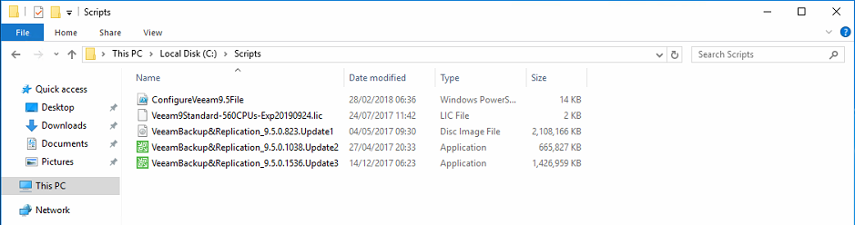

1. Mount the Veeam ISO and start the installer.

Click Veeam Backup & Replication

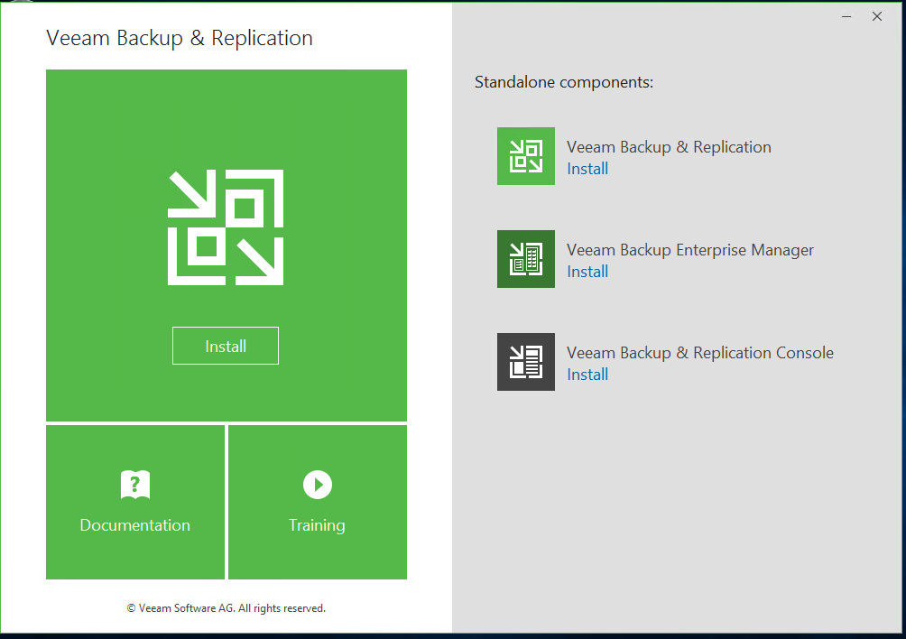

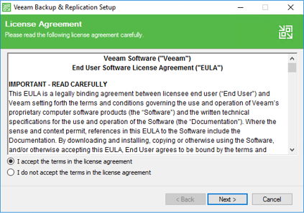

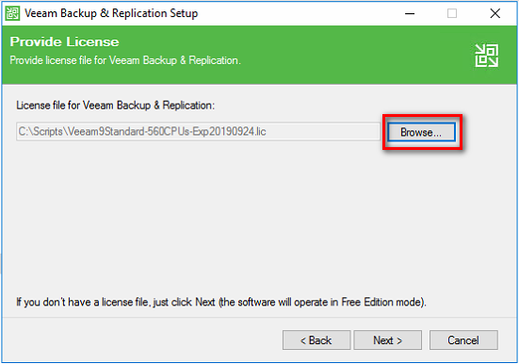

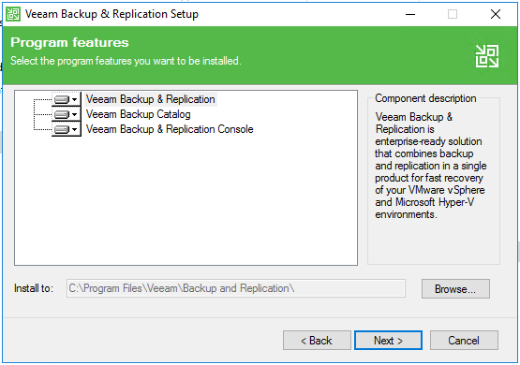

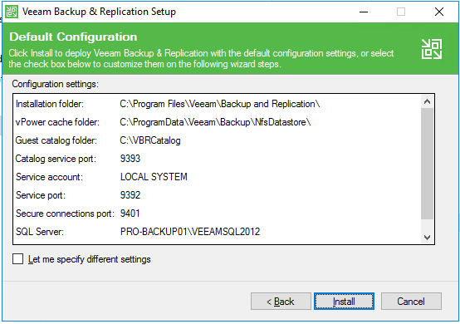

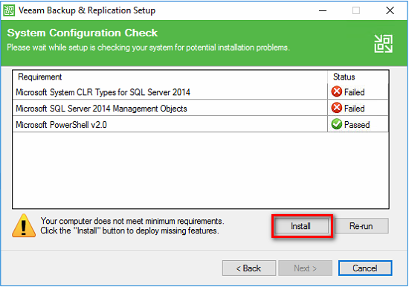

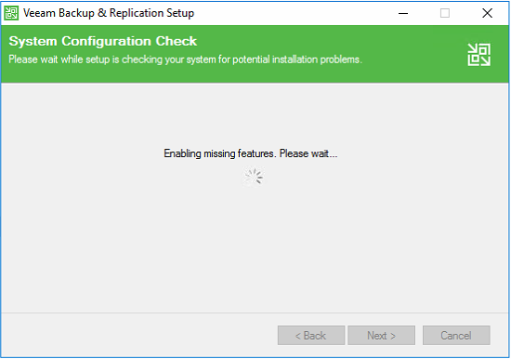

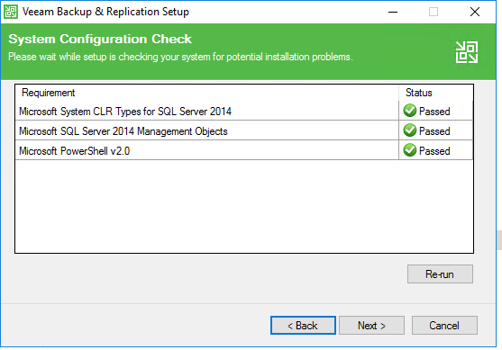

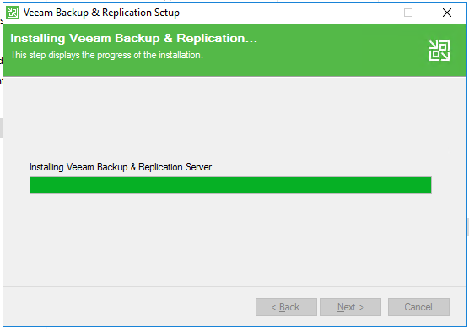

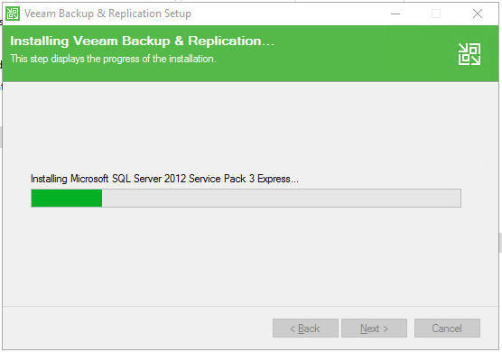

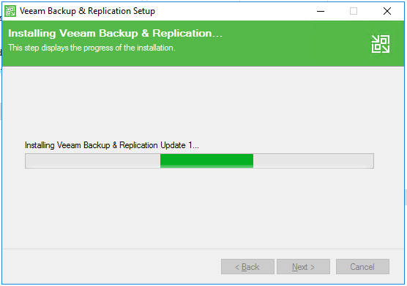

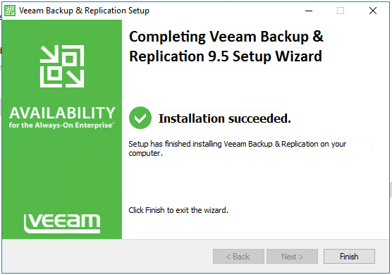

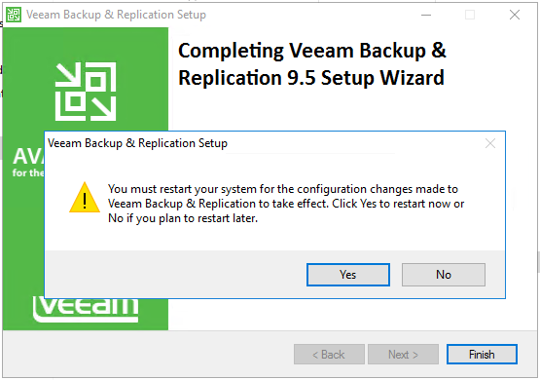

1. Update Veeam.

Launch VeeamBackup&Replication_9.5.0.1038.Update2.exe

Next >> (keep it unchecked) Install >> Finish

VeeamBackup&Replication_9.5.0.1536.Update3.exe

Next >> (keep it unchecked) Install >> Finish

After the reboot you can use the shortcut to start Veeam Backup & replication console

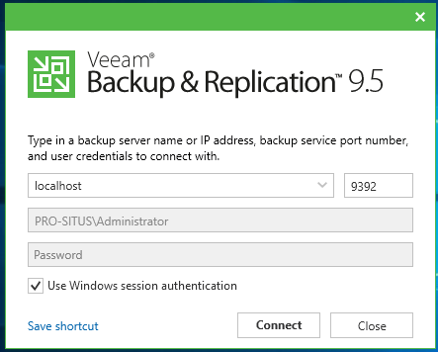

Apply

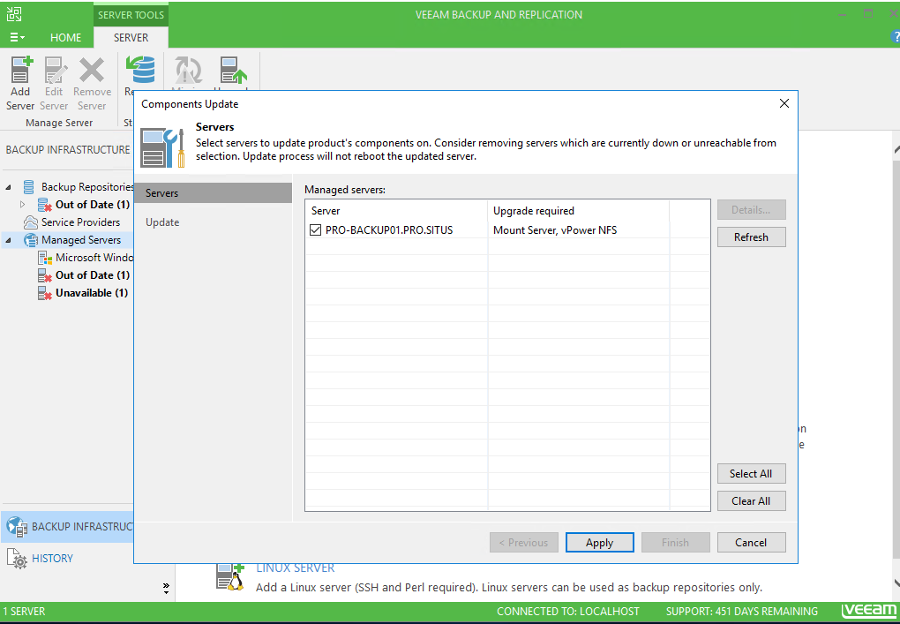

Finish and this should be the result

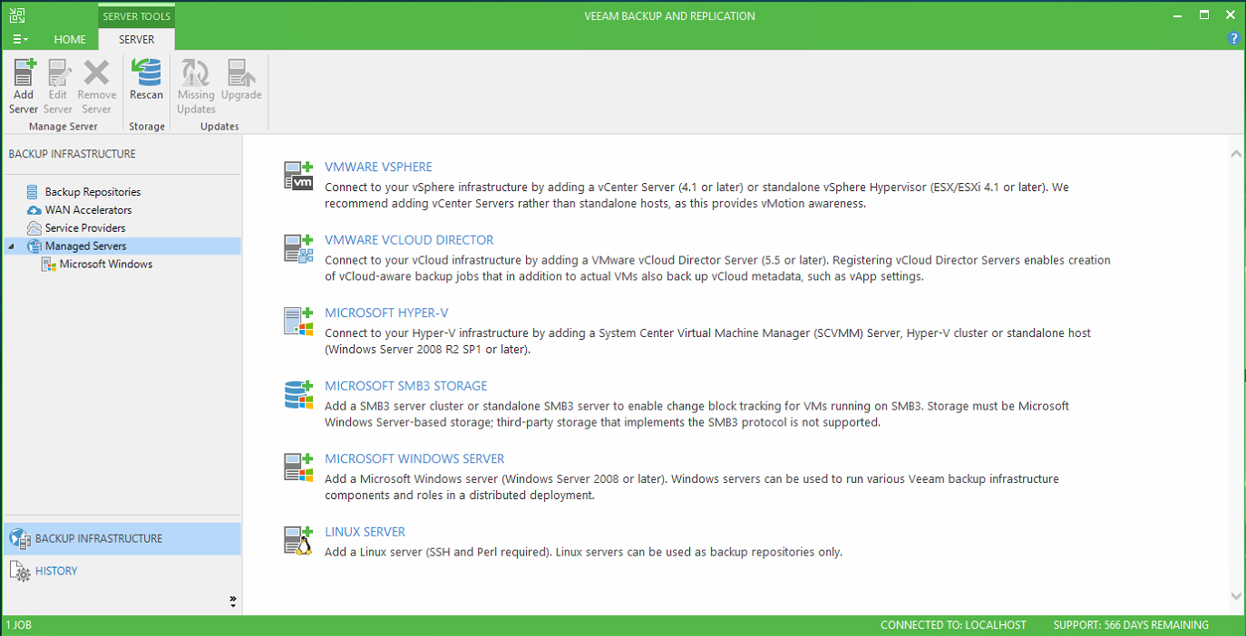

1. Before you launch the script edit the following values!

!Make sure $Site is the same as the datacenter name!

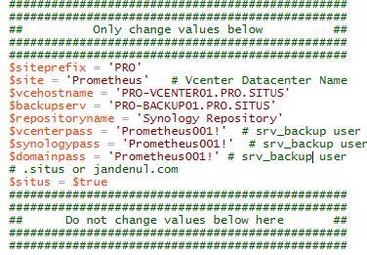

1. Open the Veeam Powershell windows

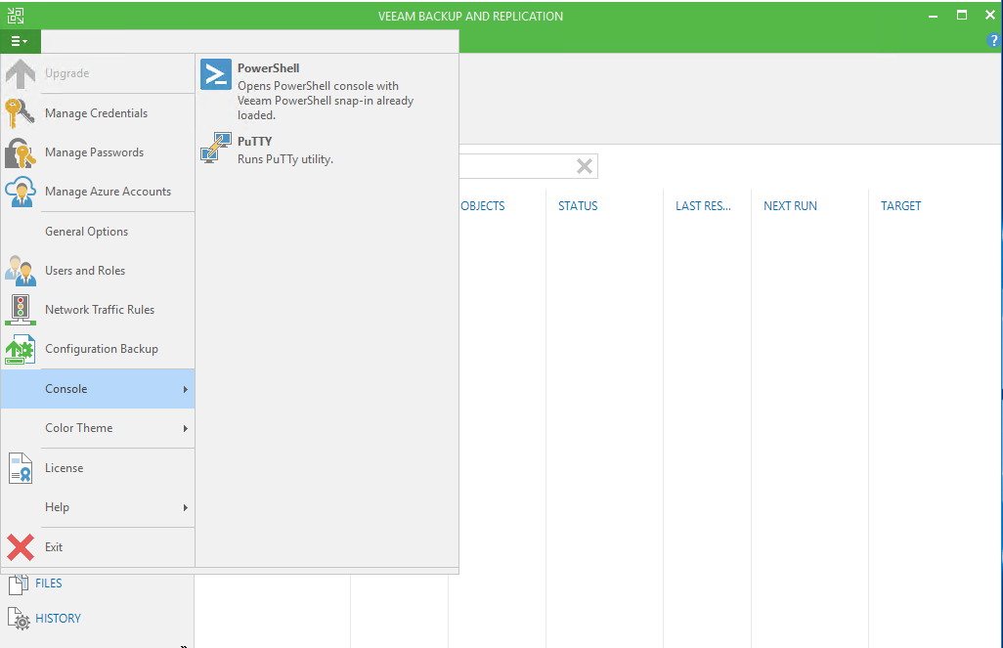

1. Cd c:\scripts

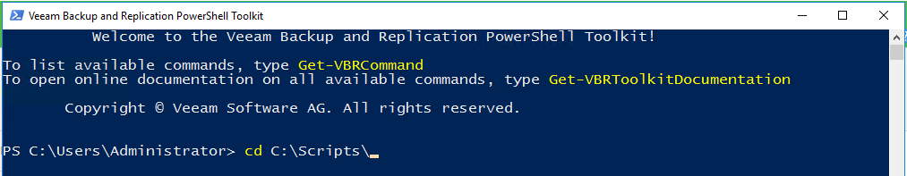

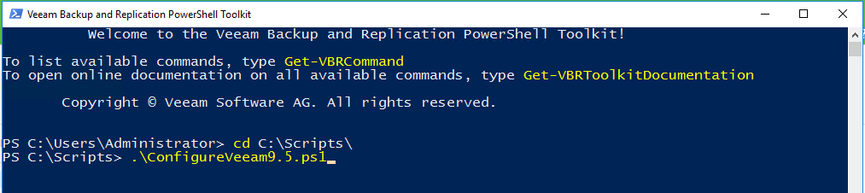

1. 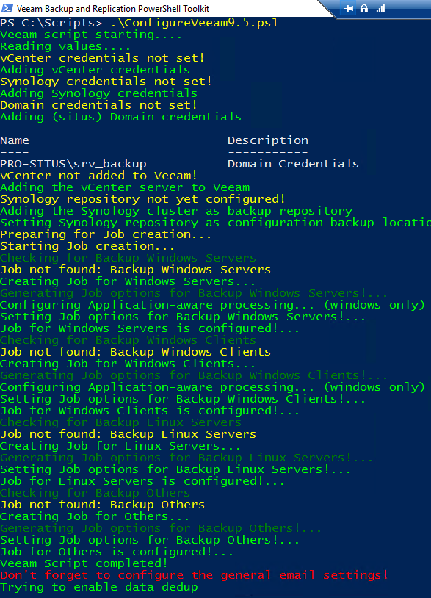Go to General Options

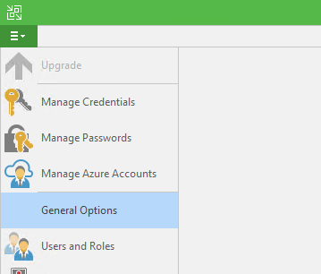

1. Fill in the correct email settings

